Mega-Light MR16-LED Downlighter:

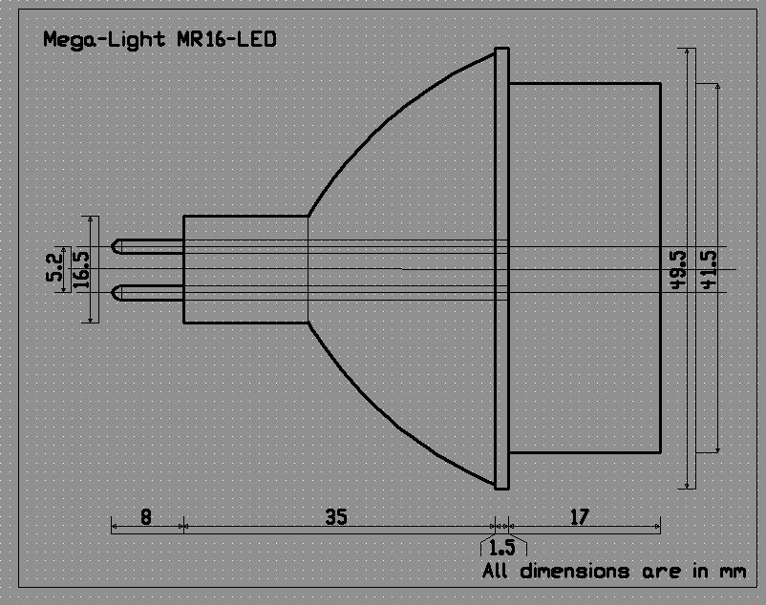

Specifications:  - Light Source: White 10mm LED  - Colour Temperature: 7000K  - Input Voltage: 10~14VAC / 8~14VDC  - Current Draw @ 12VDC: 250~370mA  - Beam Angle: 40°  - Intensity: 1000 Lumens, 400 Lux at 1m  - Nett Weight: 61g  - Operating Temp.: -40°C to +50°C  - Storage Temp.: -40°C to +80°C | Features:  - Fits standard GX 5.3 MR16 socket  - Low Voltage AC or DC operation.  - Estimated Life: At least 50,000 hours  - Applications: Retail, Ceiling Fixture,  Restaurant Lobby, Hallway, Casino,  Pub, Security Lighting, and many  other accent lighting applications.

